## CHAPTER 1

## INTRODUCTION

Home automation refers to handling and controlling home appliances by using microcontrollers or computer technology. Automation is popular now days because it provides ease, security and efficiency. In this, a sensor senses the status of appliances and updates to web server. If the user is far away from home, he can access and change status of appliances i.e. switch it on/off. User can use local PC. This paper will describe approach of controlling home appliances by using web server.

This IOT based smart security and smart home automation systems are trying to achieve comfort combined with simplicity. Wireless Home security and Home automation are the dual aspects of this project. The currently built prototype of the system sends alerts to the owner over E-mail using the Internet if any sort of human movement is sensed near the entrance of his house .On the other hand if the owner identifies that the person entering his house is not an intruder but an unexpected guest of his then the user/owner can make arrangements such as opening the door, switching on various appliances inside the house, which are also connected and controlled by the micro-controller in the system to welcome his guest. The same can be done when the user himself enters the room and by virtue of the system he can make arrangements from his doorstep such that as soon as he enters his house he can make himself at full comfort without manually having to switch on the electrical appliances or his favorite T.V. channel for an example. Thus using the same set of sensors the dual problems of home security and home automation can be solved on a complementary basis.

One of the main advantage of this IOT is even though Wi-Fi is not available we can go through 3G or 4G services. In other existing methods it is not possible so, by overcoming all the drawbacks we have implemented a project IOT based Smart security and Smart Home Automation. This project provides more comfort combined with simplicity.

## LITERATURE REVIEW

An IOT-Based Smart Home Service System. IOT Based Smart Security and Smart Home Automation by Swapna Badabaji and Dr V Siva Nagarajuna (Istitute of Aeronautical engineeriing Hyderabad. Sudha Kousalya,G Reddy Priya (Aditya College Of Engg. Chittor) 2018. In this project, the use of a camera connected to the microcontroller might help the user in taking decision Whether to welcome the guest after receiving the captured picture of the guest or intruder, If the user identifies he is an unknown person then the user can further forward the same photograph to the police station by explaining his situation.

Development of a Prototype of an IoT Based Smart Home with Security System Flutter Mobile IoT Based Home Automation Nur Asyiqin Bt. Amir Hamzah1,Muhammad Radzi B. Abu Saad2, Wan Zakiah Bt. Wan Ismail Ayush Doshi Deep Vakharia Yashraj Rai 2019 2021. In this project they managed to develop a prototype which demonstrated safety and smart functionalities of an IoT based smart home system a total of 5 senses were used in this prototype to detect movement, fire, flood and turning the light fan on off. Raspberry pie was used to command centre while Arduino as the device manager the challenges faced while designing the prototype also explained This research papers gives the information about the components used for making assembly simulation for the smart home automation and also gives the information on Arduino board algorithm for the sensors to workout. This also provides the information on the automation wherein it allows the users to control their devices using the Internet.

It requires the users to connect his/her appliances which he wishes to be remotely controlled to the audio circuit.

An IOT Based Smart Home Service System by Swapna Bada Baji and Dr V Siva Nagarjuna (Institute of Aeronautical engineering Hyderabad). In this paper they use IOT technology for the enhancement of safety standards. By using a WI-FI module the interfacing is done between transducers and the sensor network on a single chip solution wirelessly. They have used the IOT technology for Gas Leakage Detector, fire detection and increase of temperature, which have alerting techniques for involving and sending text message to the particular mobile phone and taking safety measures.

**CHAPTER 3**

# SYSTEM REQUIREMENT SPECIFICATION

### SOFTWARE REQUIREMENT:

* + 1. **Arduino IDE:**

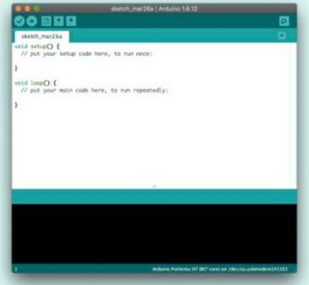

#### Fig 3.1: Arduino IDE:

The Arduino Integrated Development Environment - or Arduino Software (IDE) - contains a text editor for writing code, a message area, a text console, a toolbar with buttons for common functions and a series of menus. It connects to the Arduino hardware to upload programs and communicate with them. Programs written using Arduino Software (IDE) are called sketches. These sketches are written in the text editor and are saved with the file extension .ino. The editor has features for cutting/pasting and for searching/replacing text. The message area gives feedback while saving and exporting and also displays errors. The console displays text output by the Arduino Software (IDE), including complete error messages and other information. The bottom righthand corner of the window displays the configured board and serial port.

The toolbar buttons allow you to verify and upload programs, create, open, and save sketches, and open the serial monitor.

### HARDWARE REQUIREMENTS:

* + 1. **Arduino Uno:**

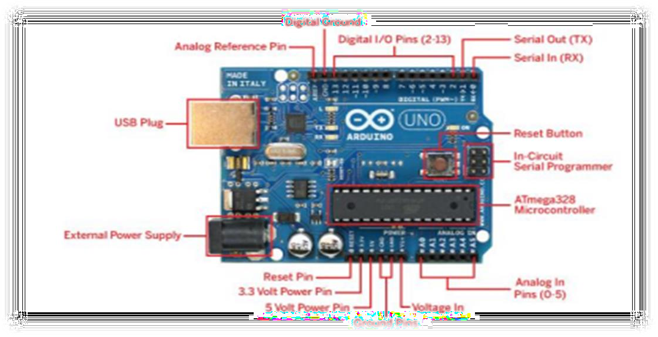

#### Fig 3.2: Arduino Uno

Arduino UNO is a low-cost, flexible, and easy-to-use programmable open-source microcontroller board that can be integrated into a variety of electronic projects. This board can be interfaced with other Arduino boards, Arduino shields, and Raspberry Pi boards and can control relays, LEDs, servos, and motors as an output.

* + 1. **RELAY MODULE**

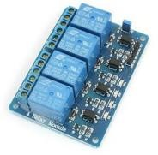

Fig 3.3: Relay

A relay is an electromagnetic switching device consisting of an armature which is moved by an electromagnet to operate one or more switch contacts. Some advantages of relays are that they provide amplification and isolation and are straight forward. Here we are using 5v 4-channel relay interface board, and each channel needs a 15-20mA driver current.it can be used to control various appliances and equipment with large current relays that work under AC250V 10A or DC30V 10A.it has a standard interface that can be controlled directly by microcontroller.

* + 1. PIR Sensor:

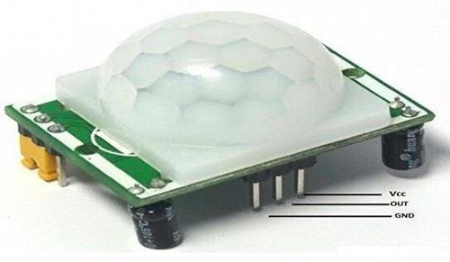

Fig 3.4: PIR Sensor

A PIR sensor detects infrared radiation emitted by objects within its field of view. The sensor itself does not emit any radiation; it only passively receives infrared radiation emitted by objects due to their temperature. This is based on the fact that all objects with a temperature above absolute zero emit infrared radiation as a result of their thermal energy.

* + 1. Door Sensor.

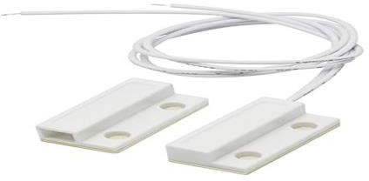

Fig 3.5: Door Sensor

A door sensor is a device used to detect the opening and closing of doors. The physics principle behind door sensors can vary depending on the specific type of sensor used. One common type of door sensor uses a magnetic reed switch. A magnetic reed switch consists of two thin, flexible metal reeds encased in a glass tube. When a magnetic field is applied to the reed switch (as when a door is closed), the reeds are attracted to each other and the switch closes. When the magnetic field is removed (as when a door is opened), the reeds separate and the switch opens. This change in the magnetic field state is detected electronically and used to determine the door's status.

### Jumper wires:

#### Fig 3.6: Jumper wires

Jumper wires are simply wires that have connector pins at each end, allowing them to be used to connect two points to each other without soldering. Jumper wires are typically used with breadboards and other prototyping tools in order to make it easy to change a circuit as needed. A jumper wire is an electric wire that connects remote electric circuits used for printed circuit boards. By attaching a jumper wire on the circuit, it can be short-circuited and short-cut (jump) to the electric circuit.

**CHAPTER 4**

**IMPLEMENTATION**

Below is the snippet of the code to be uploaded to Arduino IDE

int pir = 3; // PIR sensor pin

int doorpin = 2; // Door sensor pin

int led = 5; // LED pin

int buzz = 4; // Buzzer pin

void setup() {

Serial.begin(9600);

pinMode(pir, INPUT);

pinMode(doorpin, INPUT_PULLUP);

pinMode(led, OUTPUT);

pinMode(buzz, OUTPUT);

}

void loop() {

int pirValue = digitalRead(pir);

int doorStatus = digitalRead(doorpin);

Serial.print("Motion: ");

Serial.print(pirValue);

Serial.print(" | Door: ");

Serial.println(doorStatus);

// Display door status

if (doorStatus == HIGH) {

Serial.println("The door is opened");

} else {

Serial.println("The door is closed");

}

delay(10000);

// Check conditions for LED and buzzer control

if (pirValue == HIGH || doorStatus == HIGH) {

digitalWrite(led, HIGH);

digitalWrite(buzz, HIGH); // Turn on the buzzer

Serial.println("Warning: Motion detected or door opened!");

} else {

digitalWrite(led, LOW);

digitalWrite(buzz, LOW); // Turn off the buzzer

}

delay(100); // Adjust delay as needed

}

**Circuit diagram:**

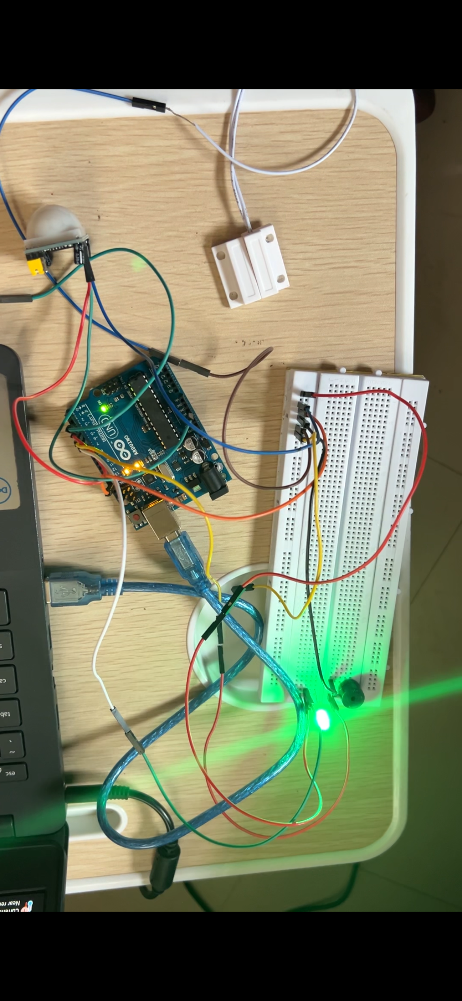

#### Fig 4.1: Circuit Diagram

## Model Working

Under this environment monitoring, we are using DHT11. This sensor is more useful to know about weather condition, In this project we are placing this sensor inside the home to know the weather condition of our home. Here DHT11 sensor shows the values of humidity and temperature . For every second it will shows the new value in our mobile phone. If the temperature becomes high at that time we can switch on the led and buzzer to give alert.

As a smart security system

If we place a PIR sensor at the entrance of a building. These sensors as explained earlier detect the motion of obstacle. This signal which detects their presence becomes the input trigger for the micro-controller. In this We are also used Door sensor which also gives the alert that door is opened or closed.The motion detected will be given as input to the microcontroller it wil give the signal to on the led on and buzzer starts to make sound.

**ADVANTAGES**

1. This low cost system with minimum requirements takes Care of both home security as well as Home automation.
2. More helpful for handicapped and aged people.
3. Devices can be controlled from long distance.

Highly secured and Time saving.

## CONCLUSION

Internet of things based home automation system can only work in the presence of internet. The rapid growth of IoT devices brings concerns and benefits. Even though Wi-Fi is not available we can go to 3G or 4G services. This is one big advantage of IOT. In this project, the use of a Bluetooth module connected to the microcontroller might help the user in taking decision whether to open or close the door indirectly welcome the respective person or not if the temperature reading is more than the specified value then it gives alert to switch of the geysor like devices. This project can also be implemented by using Raspberry.

## REFERENCES.

1. A. R. C. Y. . O. K. Withanage, C., “A comparison of the popular home automation technologies,” pp. 1 – 11, may 2014.
2. R. Piyare and M. Tazil, "Bluetooth based home automation system using cell phone," Consumer Electronics (ISCE), 2011 IEEE 15th International Symposium on, Singapore, 2011, pp. 192-195.
3. P. Kumar and U. C. Pati, “IOT-based Monitoring and Control of Appliances for Smart Home,” 2016 IEEE Int. Conf. Recent Trends Electron. Inf. Commun. Technol. (RTEICT), vol. 769008, pp. 1145– 1150, 2017.
4. P. Neumann, “Development of a Prototype of the " Smart Home " System Development of A Prototype of the ‘ Smart Home ’ System,” no. May 2015, 2016.
5. R. K. Kodali, V. Jain, S. Bose and L. Boppana, “IoT based Smart Security and Home Automation System,” Proceeding - IEEE Int. Conf. Comput. Commun. Autom. (ICCCA), pp. 1286–1289, 2017.

[6]. Nishanthini, S., M. Abinaya, and S. Malathi. "Smart Video Surveillance system and alert with image capturing using android smart phones." In Circuit, Power and Computing Technologies (ICCPCT), 2014 International Conference on, pp. 1714-1722. IEEE, 2014.

[7] IOT based Smart Home Gowri.J1 & Akshaya.R2 & Dhanalakshmi.V. 3 1,2,3Department of BCA and M.Sc.SS, Sri Krishna Arts and Science College, Coimbatore, Tamil Nadu, India. [VOLUME 6 I ISSUE 1 I JAN. – MARCH 2019] IEEE.